**A/B Test Plan**

**Objective:** The objective of this A/B test is to evaluate the effectiveness of a modified user consent form (Version B) compared to the original consent form (Version A) in terms of user interaction and satisfaction.

**Versions to Test:** 1. **Version A (Original):** Requires users to scroll through the entire user agreement before the “Next” button becomes available. 2. **Version B (Modified):** Activates the “Agree” button immediately upon reaching a certain part of the agreement, simplifying the consent process.

**Hypothesis:** We hypothesize that Version B will result in higher user satisfaction and interaction rates compared to Version A due to its simplified consent process.

**Test Procedure:**

1. **Preparation (1 minute):**
   * Ensure that both Version A and Version B are implemented correctly and are accessible for testing.
   * Prepare the survey questions for gathering user feedback.
2. **User Test (4 minutes):**
   * Randomly assign half of the users to Version A and the other half to Version B.
   * Instruct users to navigate through the user consent form as they normally would during the onboarding process.
   * Measure the time taken to complete the consent process and note any observations or difficulties faced by the users.
   * Monitor user reactions and gather qualitative feedback during the test.
3. **Survey (1 minute):**
   * After completing the user test, present users with a brief survey to gather feedback on their experience with the consent form.
   * Survey questions may include:
     + How easy was it to understand and agree to the terms with the consent form?
     + Did you encounter any issues or confusion during the consent process?
     + Rate your overall satisfaction with the consent form interaction (on a scale of 1 to 5).
   * Ensure the survey is brief to encourage maximum participation and honest responses.
   * Group A: https://forms.office.com/e/JVEh3L6PpK
   * Group B: https://forms.office.com/e/gipnsbPK3U
4. **Data Analysis:**
   * Compile and analyze the data collected from the user test and survey.
   * Compare completion times, user feedback, and satisfaction ratings between Version A and Version B.
   * Determine if Version B shows statistically significant improvements in user interaction and satisfaction compared to Version A.

**Conclusion:** Based on the results of the A/B test, we will identify which version of the user consent form (Version A or Version B) provides a better user experience and decide on further implementation based on the findings.

LINKS:

– Group A: https://forms.office.com/e/JVEh3L6PpK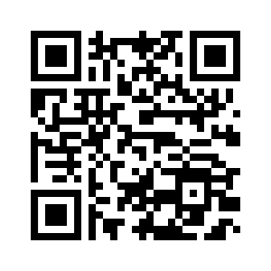

Group B: <https://forms.office.com/e/gipnsbPK3U>

